|  |
| --- |
| TRAINING PACK  2018 |

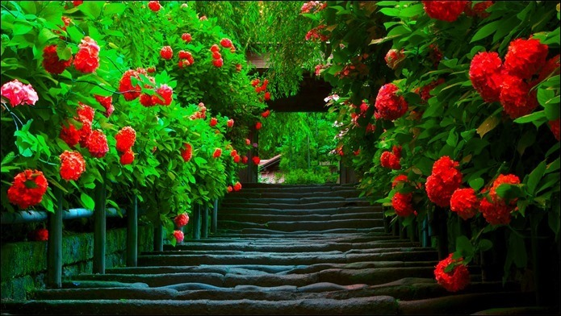

|  |  |  |
| --- | --- | --- |
| SCK HOLDINGS COMPANY (PVT) LTD. |  |  |
| Author: K.P.I. Shenesh Perera  IDM | Head Project Manager |  |

TABLE OF CONTENTS

Introduction 3

Strategic Highlights 3

Financial Highlights 3

Teamwork... 3

Who is this training pack for? 3

Guidance for the presenter 4

Aims and objectives 4

Requirements to run this session 4

Training session plan 5

# Introduction

## Strategic Highlights

It is crucial to understand that this training pack will be the sole basis of how the employees will proceed to see team work from this point on, as such every task must be executed exactly as detailed in this training pack

## Financial Highlights

We thank SCK Holdings for financing our purchasing orders in order to make this project a reality.

## Teamwork...

The team behind me, the author, worked very hard to make this project a success.

|  |
| --- |
| ***"Talent wins games, but teamwork and intelligence win championships." --Michael Jordan*** |

## Who is this training pack for?

This training pack is primarily aimed at staff and any other volunteers working within SCK Holdings in order to help them improve their existing understanding or spark an understanding of teamwork. The pack revolves around YouTube videos. The pack contains a guide for facilitating a 2-hour training session of up to 40 employees per instance.

# Guidance for the presenter

It is strongly recommended that you read through the guide and also refer to the YouTube videos at least once to see if the videos make sense to you in case the audience questions you. It may also prove useful if you could write some information before you begin.

## Aims and objectives

To equip a work force with team working spirit so that they can become more efficient push forward thereby improving the standards of SCK Holdings.

## Requirements to run this session

* A training room, large enough for 60 people, with seating arrangements for 4 per table, alongside a set of clipped 5 A4 papers, and a black pen each.
* A projector and possibly an interactive whiteboard in order to display the videos.
* If projectors aren’t available a TV or monitor that is large enough for the audience, will suffice.
* Speakers set in a manner that it is not too loud for the front tables and not too quiet for back tables.
* Refreshments for breaks, typically sandwiches and juice and lunch arranged.
* A copy of the movie Take the Lead (2006).
* A teamwork expert must be hired to do a course of 2 seminars.
* A minimum of 8 hours per day arranged.

# Training session plan

Introducing the session (appox. 45 minutes)

The presenter should begin by asking each individual team of 4 people to start by naming their team, introduce the team and share any inspirational experiences of team building. These teams shouldn’t have any leaders, or simply all of them are leaders. Make sure the introductions and experiences that are shared are brief.

Activity One – Show videos (approx. 30 minutes)

The following videos must be shown one after the other, make sure that the first videos “&t=17s” part is pasted into the browser address bar as the intro for that video is quite unprofessional.

https://www.youtube.com/watch?v=O-Hzzg1AtVs&t=17s

https://www.youtube.com/watch?v=fm1gh5GAmWc <https://www.youtube.com/watch?v=6fbE52YDEjU>

After showing these videos ask each team to briefly express what they understood by watching them, as the presenter you can grade their understanding and display it on a scoreboard, this is to improve competition amongst teams.

It must be later pointed out that competition is one of the simplest reasons why teamwork is necessary.

Activity Two – Tug of war (approx. 2 hours)

Teams of 4 must be put against each other, make sure that teams that are physically weak go against weak teams but do not make this point obvious. The presenter is expected to have several other members of his team to assist him to hold this competition. A scoreboard must be widely displayed. The winning team is to be gifted with a chocolate cake in the following break session.

Activity Three – Break (approx. 30 minutes)

The refreshments must be provided by the hotel, and the winning team of the competition must receive their chocolate cake when dessert is given out. Ensure that when this cake is delivered that the rest of the teams know this, this will give rise to pressure against the winning team.

Activity Four – Hangman (approx. 45 minutes)

Hangman is a guessing game, a team will come up with a word and write the number of blanks to fill out each character, fill by minimum 2 characters of the word and give a hint as to what the word is. With each wrongly guessed letter, a part of the hanged man is drawn. If the entire hanged man is drawn, then the team that came up with the word wins.

Ensure that there are only 8 chances to guess the wrong letter, and with each 2 minutes that passes, one of these chances are lost.

Add the points of winning teams to the scoreboards.

However, the previous games’ winning team must be evoked with some sort of disadvantage, this disadvantage must be reasonable for example: “You can only come up with words with 6 characters long for 2 rounds” this will make the previous winners to work harder and another team to arise.

Activity Five – Blind retriever (approx. 1 hour)

1 team member from each team is blindfolded, then the rest of the members in the team must direct the blindfolded towards the correct object among a several fake objects. Several blockades must be placed as well. The team that navigates their blind folded member to the correct object first wins.

Activity Six – Lunch Break (approx. 1 hour)

The hotel should provide lunch during this break, it must be ensured that food from anywhere else is eaten only if the employee has not paid for lunch already.

Activity Seven – Seminar (approx. 2 hours)

The hired expert in teamwork will do his seminar in this time. Teams can opt out of this seminar midway but if they do they will lose points on their scoreboard. After this seminar, the employees can go home and the session will be continued on the following day.

**DAY ONE OVER**

Activity Eight – Open discussion about previous day (approx. 1 hour)

The presenter should ask questions to gauge how the teams felt about the previous day, and base these points later for the evaluation report.

Teams must be asked questions like:

* How did yesterday make you feel individually?
* What did you learn about team work yesterday?
* Do you feel confident about yourself in a team?
* Do you think that if you had to work with this team, you will succeed?
* What is your perspective of teamwork?
* How will you use these experiences for the future?

Activity Nine – Movie (approx. 2 hours)

Take the Lead movie will be shown to the teams during this time. Teams must be encouraged to watch the movie intently as several questions will be asked later. But there will actually be no questions asked later on, this play is just to encourage viewing.

****Activity Ten – Seminar (3 hours)****

**The hired expert will then conduct a seminar talking about team dynamics, efficient work flow, leadership, types of leadership, best practices, insight on how to think, what makes a good team and a bad team etc. these topics will have assisted with videos that the expert must decide to show.**

****Activity Eleven – Final insights and brief presentation (1 hour)****

**Each team will have 20 minutes to come up with a brief presentation of 5 minutes on what they’ve learnt, how they will work from now on, the sides of them that changed, how effective this event was, and nearly any topic that describes their experience. They can use the computers in the nearby room to facilitate themselves or just present in verbal format. Each team will be graded by the presenter and points will be awarded.**

**Then the final winning team per the scoreboards will be exposed and gifted with a certificate that will demonstrate that they won and attended this event.**

****Activity Twelve - The end****

**This will be the end of the two-event, the audience can have their lunch and go home after a taking a group photo.**

****Justification****

**I believe that taking a more entertaining approach will be better off for the teams and this will surely give rise to a spirit of team work within them as such the seminars that are part of this pack is low and activities are high. This will also give rise to another crucial aspect within the company as a whole, which is the fact that these employees will get to know more about each other giving rise to a window of opportunity for teamwork in the future.**